**To Do List App**

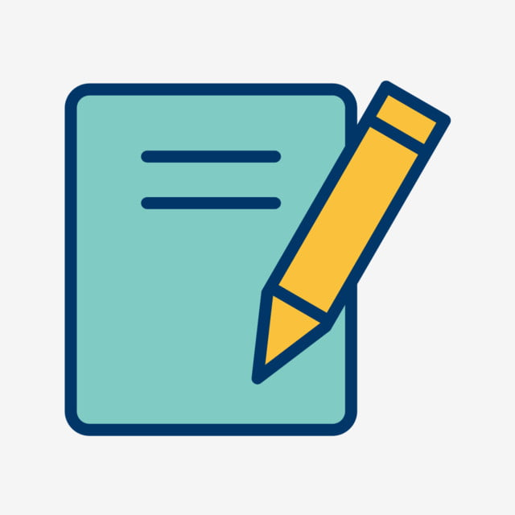**By: Dana Asulin 206027534**

**Maryanne Halabi 206537458**

**User's Options:**

1. Register the application

2. Add a task.

3. Delete a task.

4. Edit the task.

5. Prioritize the tasks.

6. Add a color to each task.

6. Add a time and date to each task.

7. Add comments to each task- the names of the participants can be added in the comments section.

8. Search tasks by keywords.

**System's Options:**

1. The application will notify the user the time has come to complete the task (send an email).

2. The 'To Do List' is presented to the user as a table.

**Heroku Link:**

<https://tdl-proj.herokuapp.com/>

**git link:**

<https://github.com/maryanne5/TO-DO-LIST.git>